SKILL9.10.11.12
9. To Change Directories, Validate Paths, Update Working Directory, Handle Errors, Maintain Previous Directory, Test Navigation.To Identify Built-ins, Create Dispatch Table, Execute In-Process Commands, Handle Invalid Commands, Maintain State, Test Dispatch Logic
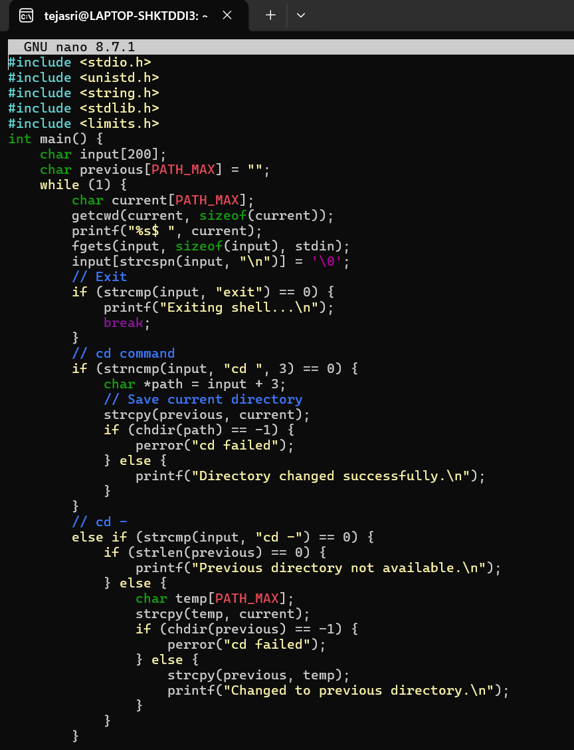

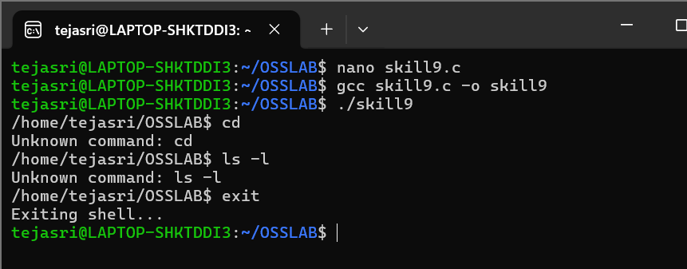
11. To Store Commands, Maintain History Buffer, Handle Capacity Limits, Retrieve Entries, Display History, Validate Consistency.To Create Pipeline Structures, Store Commands, Maintain Execution Order, Connect Processes, Validate Pipeline Layout, Test Configurations
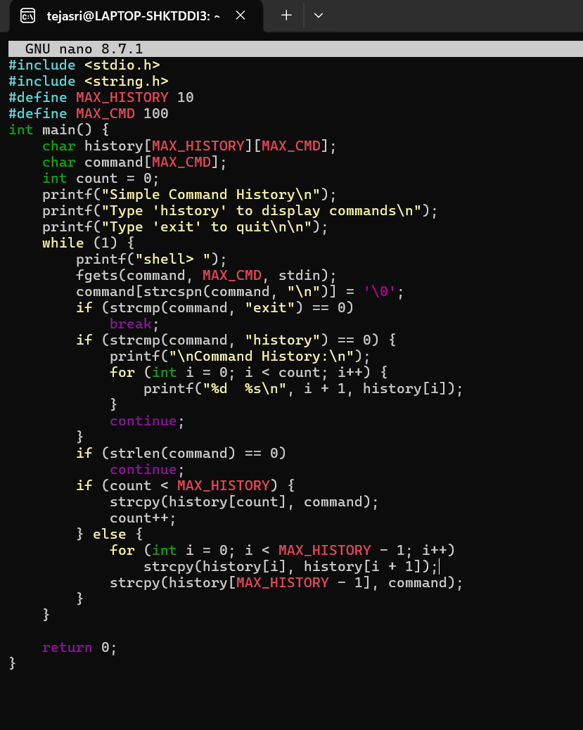

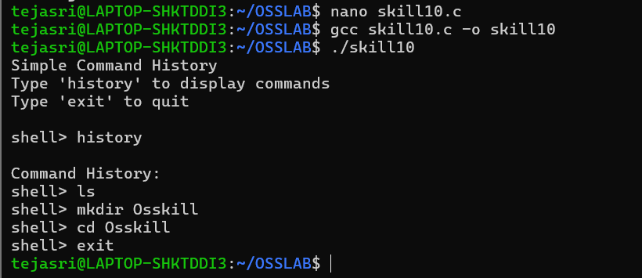
10. To Retrieve Current Directory, Display Path, Process Exit Requests, Cleanup Resources, Save State, Verify Correct Behavior.
To Parse Export Syntax, Update Environment Variables, Validate Names, Handle Existing Variables, Export to Child Processes, Test Functionality.

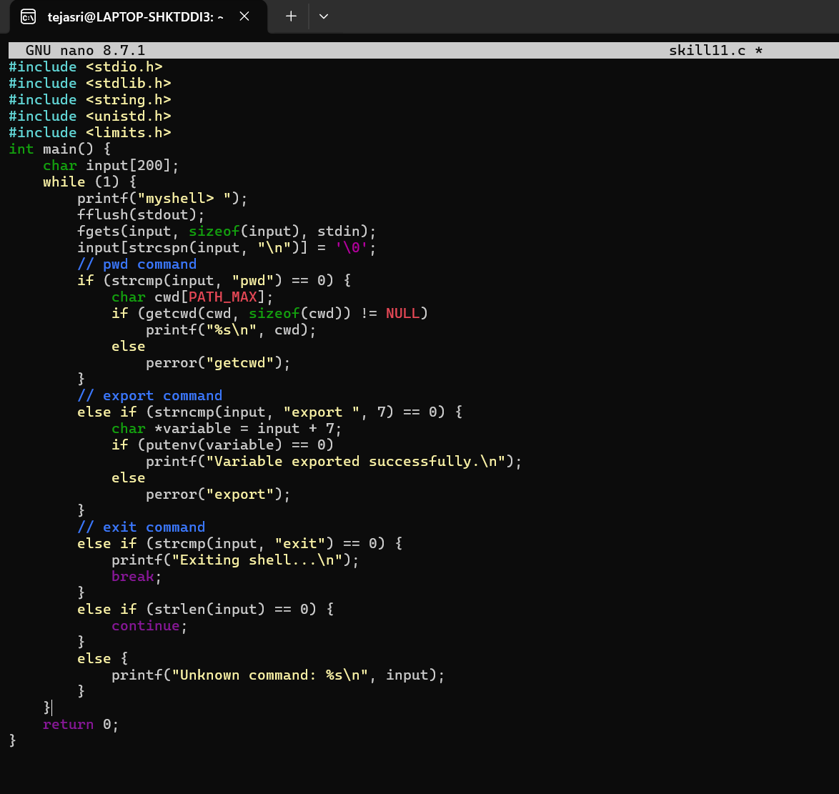
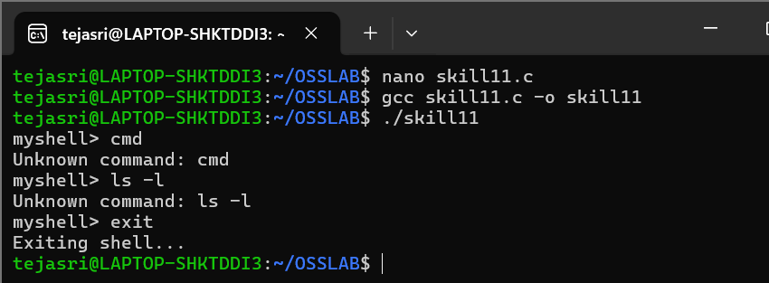
12. To Create Pipes, Redirect Streams, Execute Connected Commands, Close Descriptors, Synchronize Processes, Test Data Flow.

To Support Multiple Pipes, Manage Descriptor Arrays, Launch Multiple Processes, Coordinate Execution, Cleanup Resources, Test Long Pipelines.

